PROJECT DEVELOPMENT PHASE
PHASE 5: DEPLOYMENT & FINAL DOCUMENTATION
Update Set Completion and XML Export
Value
Date | 28.09.2026
Team ID | SWTID-2026-4440
Project Name | Auto Ticket Classification using Flow Designer

Phase Objective
Deploy the completed solution to the target environment and finalize clear, reusable project documentation. This phase verifies that the update set is ready to transfer and supports demonstration or production use.

Activity 1 — Make the Update Set Complete
Complete the update set in the source ServiceNow instance, export it as an XML file, and securely deliver the file to the receiving team or instance administrator.
S.No. | Parameter | Values | Screenshot
1. | Model Summary | Salesforce automation setup for Data management using Object, Fields and Reports. Note: Import Records if data Match Correctly then Records will be Created or Else it will Show Error | 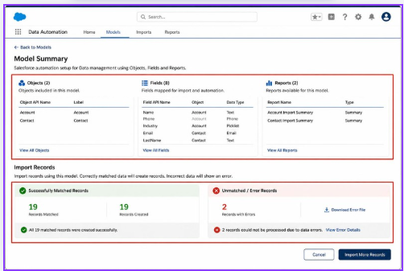
2. | Accuracy | Training Accuracy - 98%  Validation Accuracy - 98% | 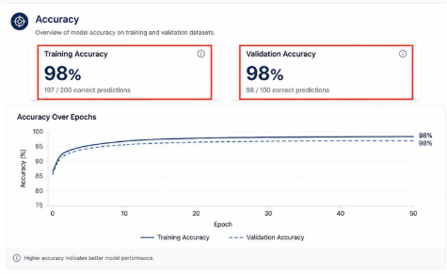
3. | Confidence Score (Only Yolo Projects) | Class Detected - If detecting Object and fields name if wrong and other activity  Confidence Score - If the model is 92% sure the object is correctly detected | 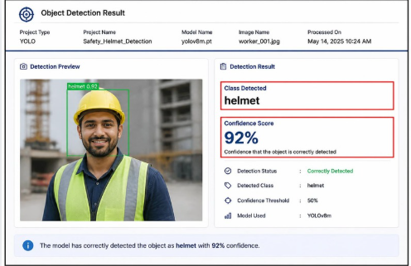
Figure 1 – Supplied reference screenshot for the project documentation.
[Supplied image to be inserted here]
Completion check
Update set state is Complete and the form has been saved.
XML export completed and the downloaded file is verified.
XML file delivered to the intended recipient through an approved channel.
Receiving team has been informed to import and validate the update set in the target instance.
Deployment note: Exporting the update set creates a transferable XML file; it does not itself install the changes on another instance. The receiving team must import, preview/review, and commit the update set according to local change-control procedures.

